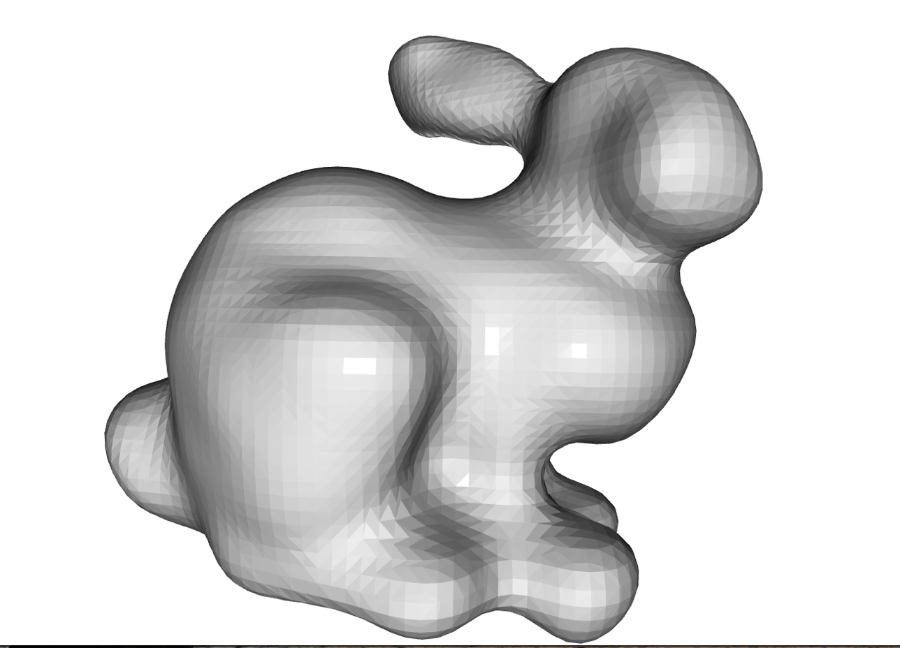A

Figure : Bunny-1000

Figure : Bunny 500

Figure : Sphere-mls

Figure : sphere-naive

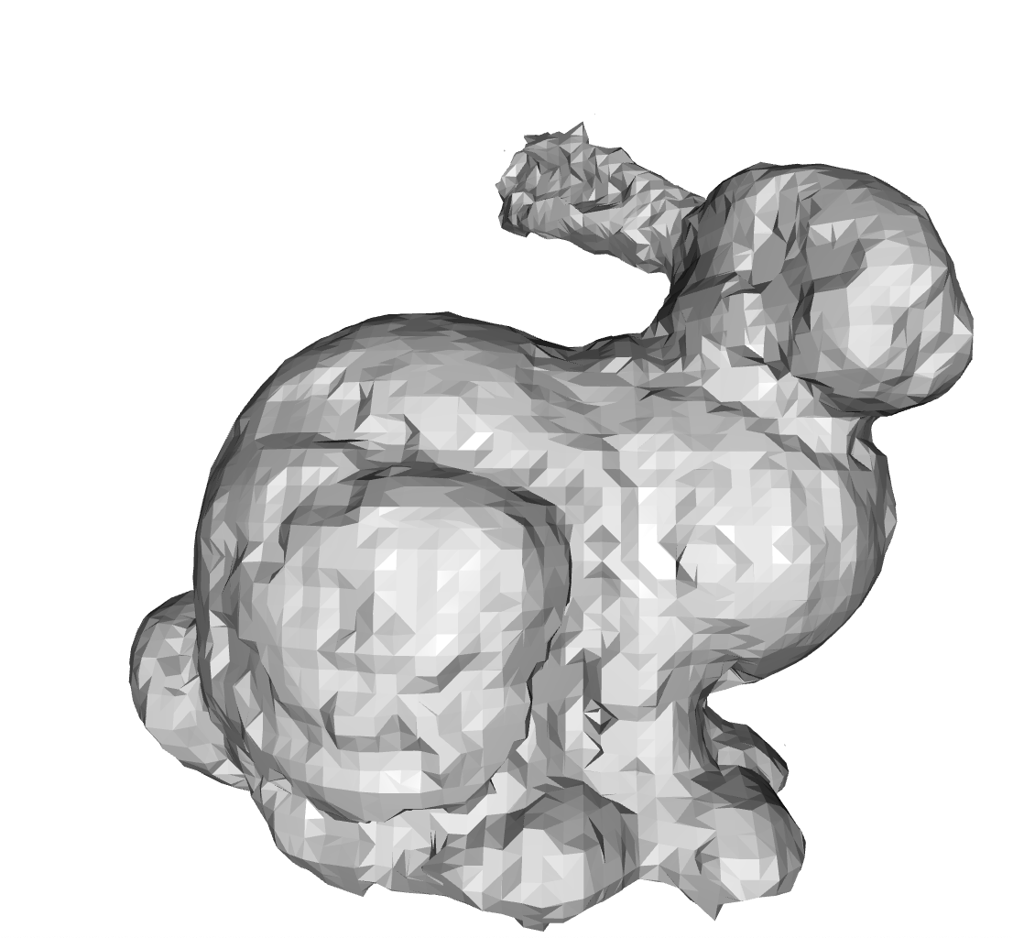

Figure : Bunny-1000-naive

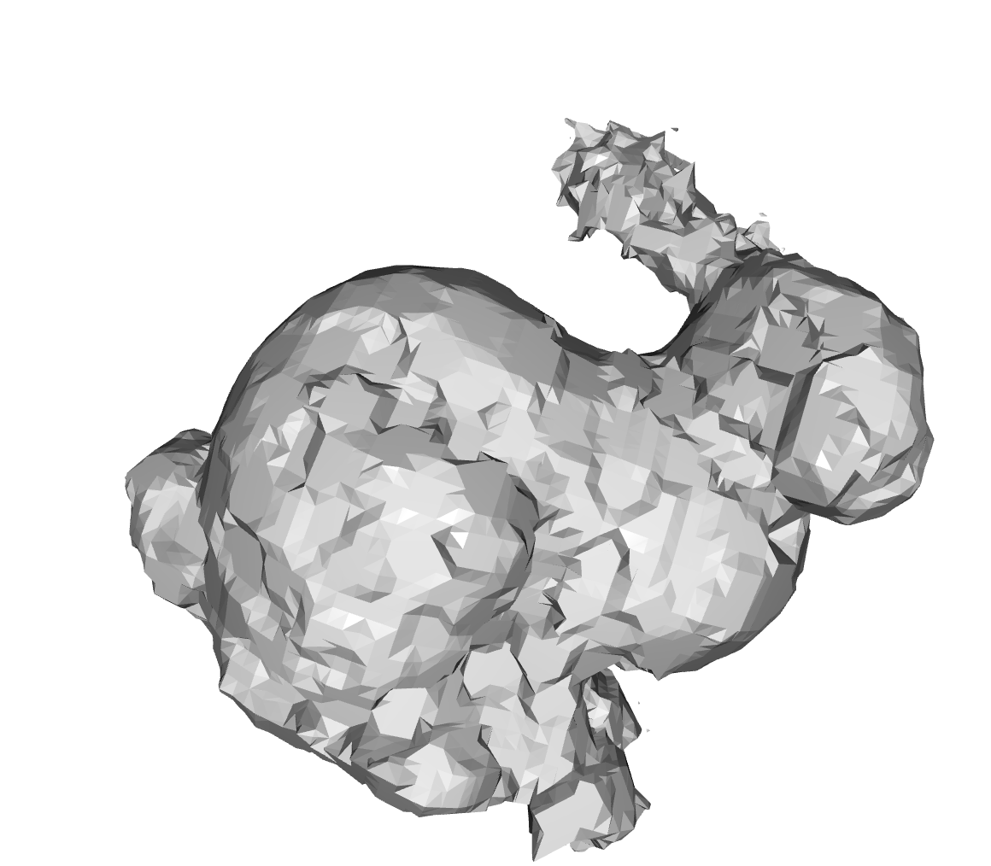

Figure :Bunny-500-naive